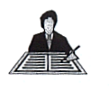Task No 12

How do you see that conversation now?

